Spill Over Report (Correct Data)
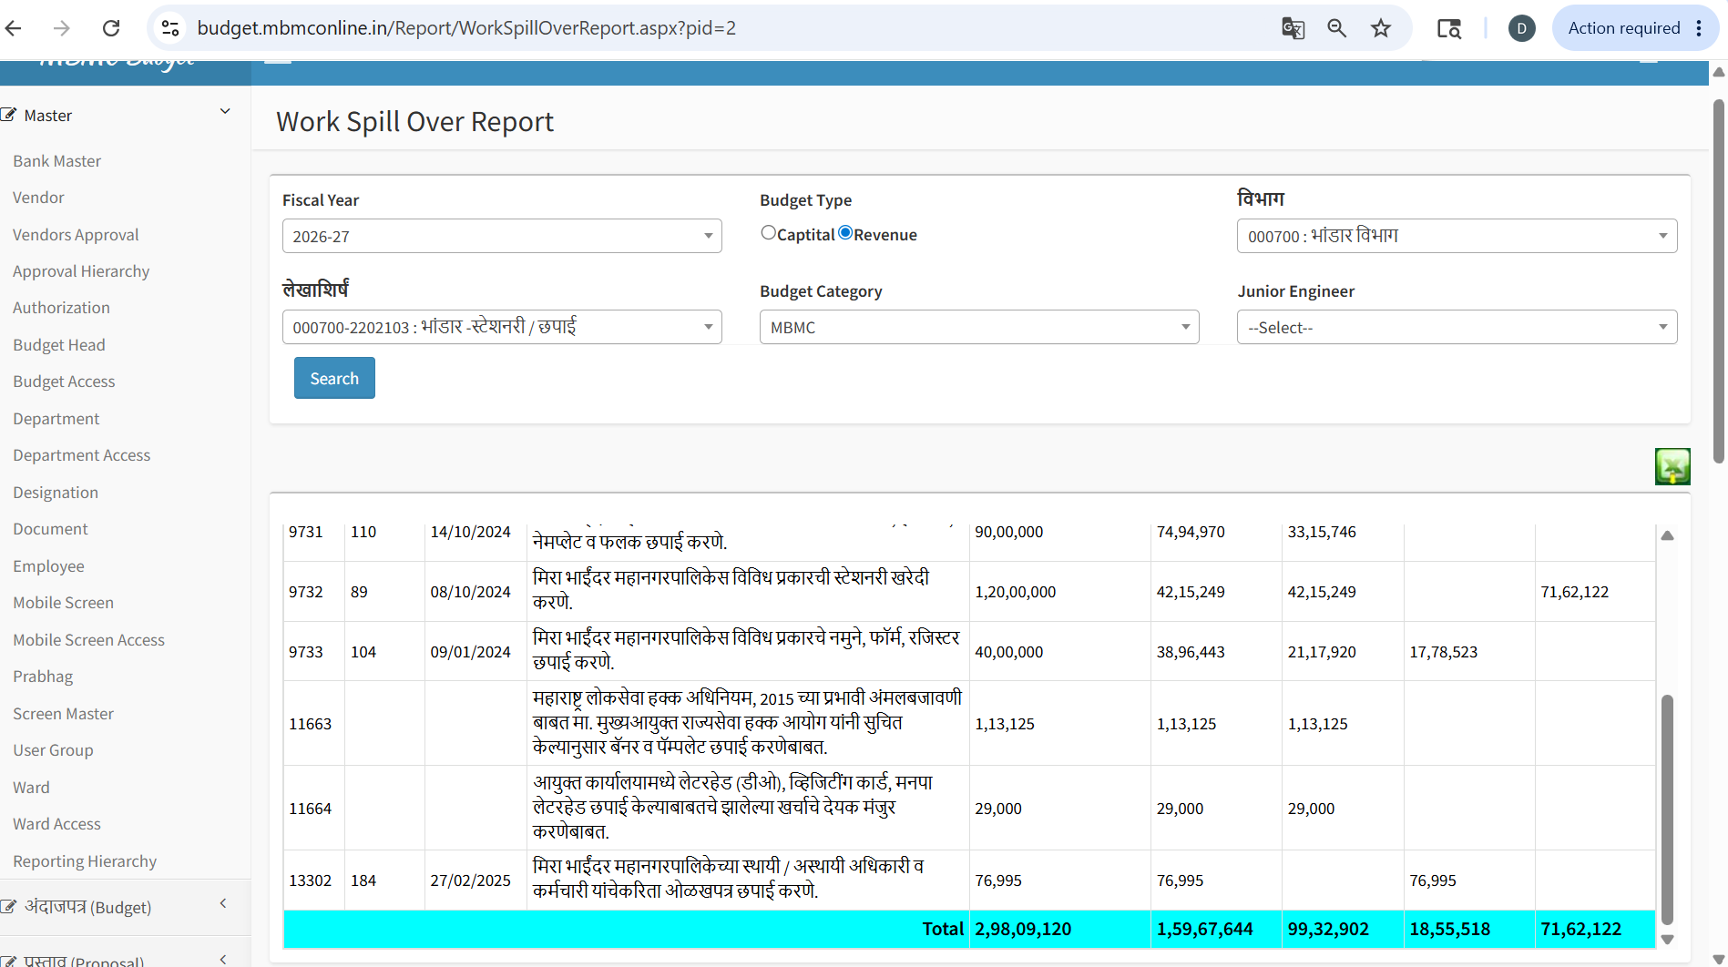

Prastav Register Report (Incorrect Numbers)
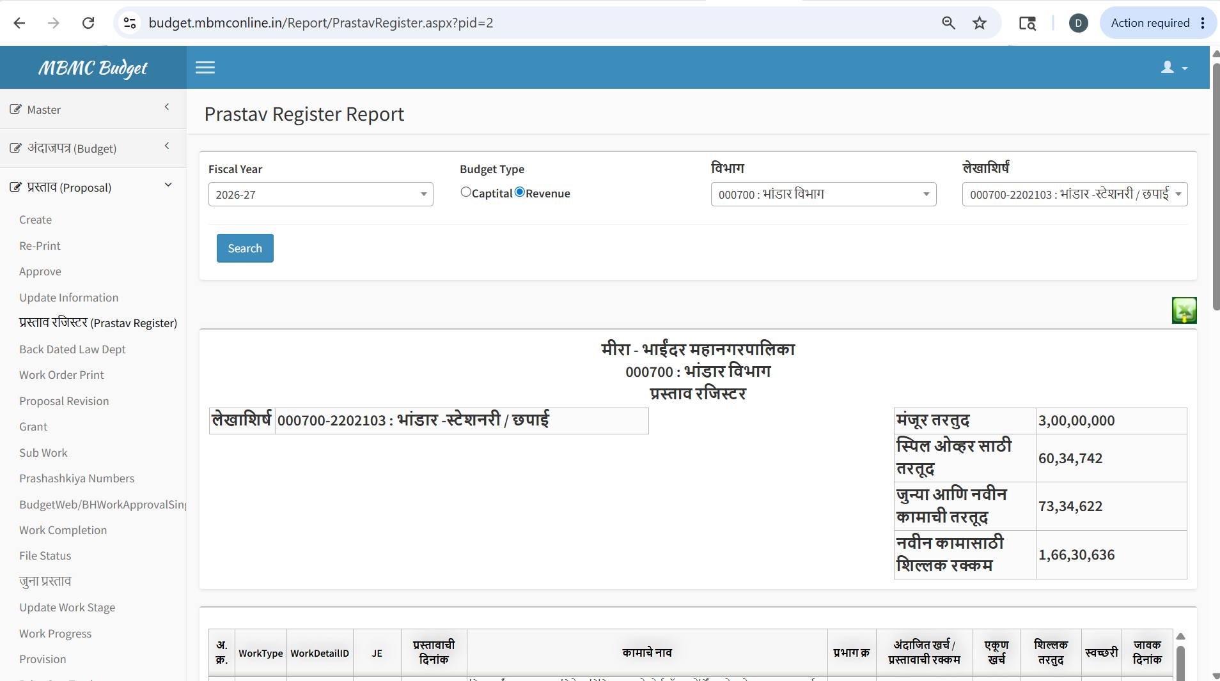

Create Proposal Screen (Incorrect Numbers)
